TERRAFORM GFG
Terraform Tutorial Link: https://developer.hashicorp.com/terraform/tutorials
Terraform Installation Link: https://developer.hashicorp.com/terraform/install\
Terraform Documentation Link: https://developer.hashicorp.com/terraform/docs
Terraform Registry Link: https://registry.terraform.io/browse/providers
In registry we can find the provider and we can get the provider code with that we can download that provider locally by using terraform init.
After finding terraform provider we can go to documentation and find all the resources block code template for all the services there and we can use that code block and edit to our use case.

Section 1: TERRAFORM INTRODUCTION:
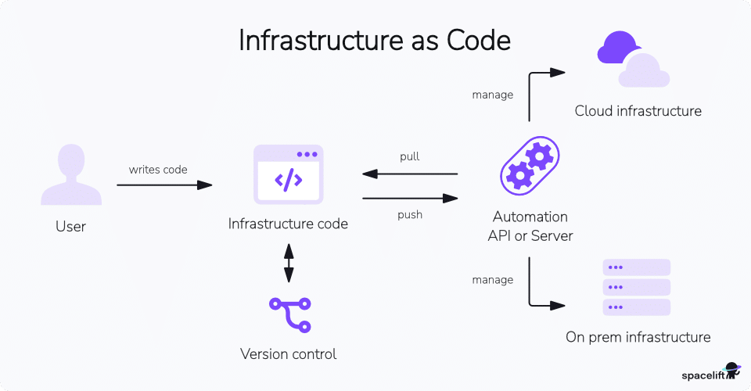
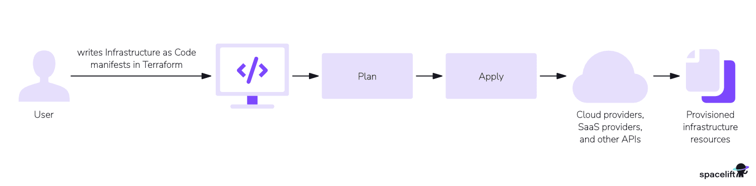
What is Terraform?
Terraform is an IaC tool that allows users to provision and manage infrastructure resources across various cloud platforms and on-premises environments. It uses declarative configuration files, written in HashiCorp Configuration Language (HCL) or JSON, to define and automate the lifecycle of resources, ensuring predictability and consistency. Terraform’s extensible plugin-based architecture supports a wide range of providers, enabling seamless integration and management of diverse infrastructure environments.
Why use Terraform?
Terraform is favored for its ability to streamline infrastructure management through code, ensuring consistency and reducing human error.
Its declarative approach allows users to define the desired state of their infrastructure, which Terraform then enforces. This capability extends across various cloud providers and on-premises environments, offering flexibility and reducing the complexity of managing multi-cloud or hybrid environments.
Moreover, Terraform’s state management and change automation features enhance team collaboration and accountability. By adopting Terraform, teams can achieve greater efficiency, scalability, and reliability in their infrastructure operations.
Terraform’s learning curve is relatively gentle, thanks to its straightforward syntax and comprehensive documentation. Beginners can start with basic concepts and gradually explore more advanced features. Its configuration files are written in HashiCorp Configuration Language (HCL) or JSON, making it accessible to those familiar with similar languages.
Key Reasons for Terraform's Creation and Advantages
- Multi-Cloud Compatibility: Many older IaC tools, like AWS CloudFormation, were single-cloud and locked users into one provider. Terraform was designed to work across all major cloud providers (AWS, Azure, GCP, etc.).
- Infrastructure Focus vs. Configuration Management: Tools like Ansible or Puppet were primarily focused on software setup and configuration within a server, not on provisioning and managing the underlying cloud infrastructure. Terraform focuses specifically on defining and managing infrastructure itself.
- Simplified Toolchain: By offering a multi-cloud, infrastructure-focused solution, Terraform allowed DevOps teams to reduce the number of separate tools they needed, simplifying workflows and management.
- Declarative Configuration: Terraform uses a simple, readable language called HashiCorp Configuration Language (HCL). Instead of writing procedural "how-to" scripts, you declaratively describe the desired state of the infrastructure, and Terraform figures out how to achieve it.
- State Management: It manages the infrastructure state, which allows for predictable and safe changes. This feature helps ensure that updates are applied correctly and that Terraform knows the current status of the deployed resources.
- Automation and Standardization: Terraform enables teams to automate and standardize infrastructure provisioning using reusable, version-controlled code, making complex cloud environment management faster and more reliable.
What is a Terraform?
Terraform is an open-source infrastructure as code (IaC) software tool that can be used to provision the infrastructure of a cloud platform. The HCL scripts used to provision infrastructure can be human-readable configuration files that can be versioned, reused, and shared. You can provision a wide range of resources in the cloud by using Terraform, like compute, storage, networking, and application services, across various cloud providers and on-premises environments.
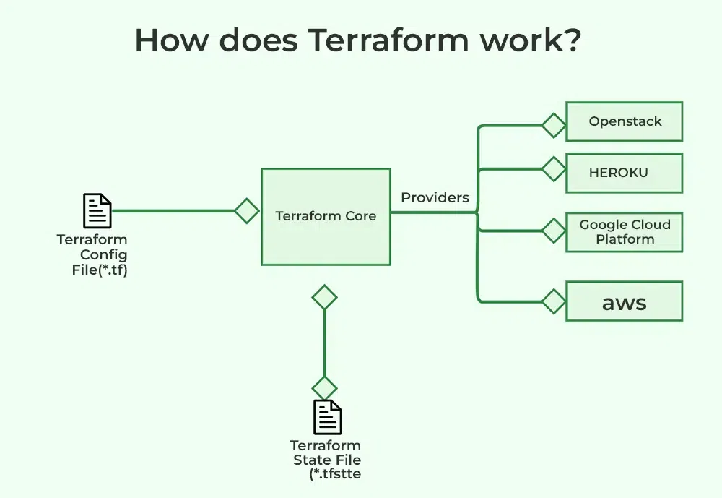
Example: How Terraform Helps in DevOps
Suppose you are working on any project in which you want to create a web server on AWS. Without Terraform, you would have to log in to the AWS website, click many buttons, and set up everything manually. This takes time and can lead to mistakes. With Terraform, you just write a short code like this:
resource "aws_instance" "web" {
ami = "ami-12345678"
instance_type = "t2.micro"
}
Then just by running terraform apply command, Terraform will automatically create the server for you. In this way you can also create multiple server by just using same script. It saves your time and reduce manual work.
Infrastructure as a Code (IaC)
Infrastructure as Code (IaC) is a method of managing and provisioning IT infrastructure(like servers,networks,databases) using code, rather than manual work. So instead of clicking buttons in a cloud dashboard, you write instructions in a file and tools like Terraform, Ansible, or CloudFormation will read that file and build everything for you. It works just like software development you can edit, share, and reuse the code, and you can track changes over time using version control systems like Git. This is particularly useful in the DevOps environment, where teams are constantly updating and deploying software.
Use Cases of Terraform:
1. Provisioning Cloud Infrastructure
Different types of cloud resources can be provisioned by using terraform like AWS,GCP and others. The resources can be managed are compute, storage, networking, and application services.
Example: A company wants to deploy 10 virtual machines and a load balancer in AWS. With Terraform, they just write the configuration once and deploy it in minutes with a single command.
2. Multi-Cloud Deployment
You can manage the infrastructure of different cloud platform at a time which will helps you to maintain the multi-cloud or hybrid cloud environments.
Example: Your application uses AWS for computing and Google Cloud for AI services. Terraform can manage both at the same time in one script.
3. Infrastructure Versioning and Collaboration
You can store the scripts which have been written to provision the infrastructure in the version control system like git form where other teams can collaborate on infrastructure changes, track revisions, and roll back to previous states if needed.
Example: A team keeps their Terraform scripts in Git. They can roll back to old infrastructure setups if something breaks just like restoring old code.
4. Saving Time by Automating Work
You don’t have to do the same setup over and over again. Just write it once and reuse it.
Example: Every time a new developer joins, Terraform can set up their cloud environment in seconds no clicks needed.
5. Managing Kubernetes Easily
Terraform can also create and manage things inside your Kubernetes cluster like pods, services, and volumes.
Example: Instead of typing long kubectl commands, you define everything in a Terraform file and apply it in one go.
6. Sharing Pre-Made Setups Across Teams
You can build Terraform modules (like templates) that others can reuse.
Example: Your team creates a ready-to-use setup for a secure database. Other teams can use the same setup without writing it from scratch.
Working of Terraform:
With Terraform, users can define infrastructure resources using a simple, declarative configuration language. These resources can include virtual machines, networking components, storage resources, and more. Once the configuration is defined, Terraform can be used to create, modify, and destroy these resources in a repeatable and predictable way.To know more about terraform work flow.
One of the key benefits of Terraform is its ability to support multiple cloud providers, as well as on-premises and open-source tools. This means that users can define infrastructure resources using a single configuration and use Terraform to manage resources across different environments.
Overall, Terraform is a powerful and flexible tool that enables users to define and manage infrastructure resources in a reusable and automated way. It is widely used in a variety of industries and scenarios, including cloud infrastructure, data centers, and hybrid environments.
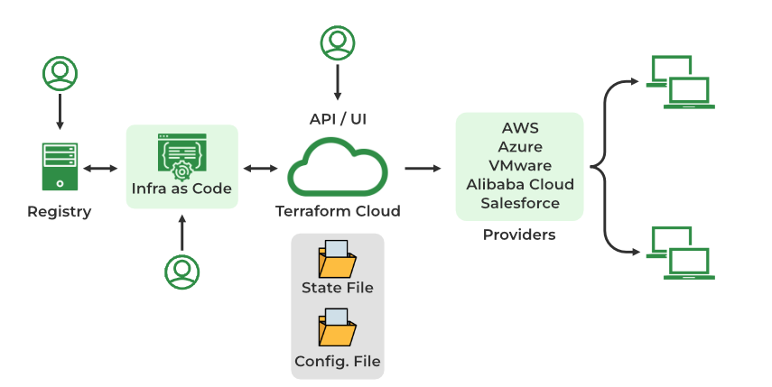
Components of Terraform Architecture:
1. Terraform Configuration Files
These files contain the definition of the infrastructure resources that Terraform will manage, as well as any input and output variables and modules. The configuration files are written in the HashiCorp Configuration Language (HCL), which is a domain-specific language designed specifically for Terraform.
2. Terraform State File
This file stores the current state of the infrastructure resources managed by Terraform statefile. The state file is used to track the resources that have been created, modified, or destroyed, and it is used to ensure that the infrastructure resources match the desired state defined in the configuration files.
3. Infrastructure as Code
Terraform allows you to use code to define and manage your infrastructure, rather than manually configuring resources through a user interface. This makes it easier to version, review, and collaborate on infrastructure changes.
4. Cloud APIs or other Infrastructure Providers
These are the APIs or other interfaces that Terraform uses to create, modify, or destroy infrastructure resources. Terraform supports multiple cloud providers, as well as on-premises and open-source tools.
5. Providers
Terraform integrates with a wide range of cloud and infrastructure providers, including AWS, Azure, GCP, and more. These providers allow Terraform to create and manage resources on those platforms.
Overall, the architecture of a Terraform deployment consists of configuration files, a state file, and a CLI that interacts with cloud APIs or other infrastructure providers to create, modify, or destroy resources. This architecture enables users to define and manage infrastructure resources in a declarative and reusable way.
Terraform Private Module Registry:
A private module registry is an internal repository for storing and distributing Terraform modules within a specific organization, rather than sharing them publicly.
Key Points:
- Purpose: Organizations use them to manage and distribute their own infrastructure code internally, offering greater control and reuse of modules compared to relying on the public Terraform Registry.
- Accessibility: They are only accessible to a specific group of users within the organization.
- Usage/Configuration:
  - Users must configure their Terraform CLI to authenticate with the registry (e.g., using an access token).
  - They must specify the registry URL in the Terraform configuration.
  - Once configured, modules are referenced using the standard module block, similar to public modules.
- Hosting: They can be hosted on various platforms, including cloud providers, on-premises servers, and open-source tools.
- Benefit: They enable organizations to better control and reuse their infrastructure code, automating and standardizing module sharing across teams.
Terraform Commands:
1. Terraform init
Terraform init command initializes a Terraform working directory by downloading and installing any required plugins and dependencies. It should be run before any other Terraform commands.
$ terraform init
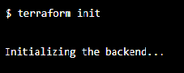
2. Terraform validate
The validate command performs precisely what its name implies. It ensures that the code is internally coherent and examines it for syntax mistakes. Only the configuration files (*.tf) in the active working directory are examined. You must provide the -a recursive flag if you want to validate files inside of folders (for example, if you have a module/ directory).
$ terraform validate
3. Terraform apply
Terraform apply command applies the changes defined in the configuration to your infrastructure. It creates or updates the resources according to the configuration, and it also prompts you to confirm the changes before applying them.
$ terraform apply
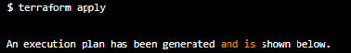
4. Terraform destroy
Terraform destroy command will destroy all the resources created by Terraform in the current working directory. It is a useful command for tearing down your infrastructure when you no longer need it.
$ terraform destroy
5. Terraform import
Imports an existing resource into the Terraform state, allowing it to be managed by Terraform.
$ terraform import

6. Terraform console
Opens an interactive console for evaluating expressions in the Terraform configuration.
$ terraform console
7. Terraform refresh
This command updates the state of your infrastructure to reflect the actual state of your resources. It is useful when you want to ensure that your Terraform state is in sync with the actual state of your infrastructure.
$ terraform refresh
Core Elements of Terraform:
1. Terraform CLI
Terraform is an open-source tool that is packaged into a single executable binary, which you can download and run directly from the command line. This tool helps you automate the creation and management of infrastructure. To see a list of available commands in Terraform, you can run:
terraform --help
This command will display all the available commands, with the most commonly used ones listed first. The primary Terraform commands include:
- init: Prepares your directory to run other Terraform commands.
- validate: Checks if the configuration is valid.
- plan: Shows what changes will be made to your infrastructure.
- apply: Executes the changes to create or modify your infrastructure.
- destroy: Deletes the infrastructure that was previously created.
2. Terraform Language
Terraform uses HashiCorp Configuration Language (HCL) to define infrastructure. HCL is designed to be both easy to read by humans and understandable by machines, making it a great fit for DevOps tools.
Infrastructure elements managed by Terraform are called resources. These can include virtual machines, S3 buckets, VPCs, and databases. Each resource is defined in a block, like this example for creating an AWS VPC:
resource "aws_vpc" "default_vpc" {
cidr_block = "172.31.0.0/16"
tags = {
Name = "example_vpc"
}
}
3. Terraform Provider
A software element known as a Terraform provider enables Terraform to communicate with a particular infrastructure platform. The resource kinds and data sources that Terraform can handle for that platform must be implemented by providers.Cloud platforms, data centres, network devices, databases, and other resources inside the target infrastructure or service can all be defined, configured, and managed by Terraform providers.
4. Terraform Modules
In Terraform, a module is a container for a set of related resources that are used together to perform a specific task. Modules allow users to organize and reuse their infrastructure code, making it easier to manage complex infrastructure deployments.
Modules are defined using the ' module ' block in Terraform configuration. A module block takes the following arguments:
- source: The source location of the module. This can be a local path or a URL.
- name: The name of the module. This is used to reference the module in other parts of the configuration.
- version: The version of the module to use. This is optional and can be used to specify a specific version of the module.
Inside a module block, users can define the resources that make up the module, as well as any input and output variables that the module exposes. Input variables allow users to pass values into the module when it is called, and output variables allow the module to return values to the calling configuration. Modules can be nested, allowing users to create complex infrastructure architectures using a hierarchical structure. Modules can also be published and shared on the Terraform Registry, enabling users to reuse and extend the infrastructure code of others.
5. Terraform Provisioners
Provisioners are special tools in Terraform that let you execute commands on your infrastructure after it’s been created. For example, you can use provisioners to copy files to a virtual machine or run scripts for further configuration.
However, provisioners should be used with caution because they can complicate your setup and may require higher-level permissions. It’s best to only use them when no other Terraform constructs (like resources or modules) can achieve the same result.
6. Terraform State
Terraform keeps track of your infrastructure and its current state in a file called terraform.tfstate. This file contains information about your infrastructure resources, which helps Terraform determine what changes to make during future operations.
The state can be stored locally on your machine, but in collaborative settings, it's usually better to store it remotely to ensure everyone on the team is working with the same state information.
Advantages of Terraform:
- Declarative Configuration: Terraform uses a declarative configuration language, which means that users define the desired state of their infrastructure resources, rather than the specific steps required to achieve that state. This makes it easier to understand and manage complex infrastructure deployments.
- Support for Multiple Cloud Providers: Terraform supports multiple cloud providers, as well as on-premises and open-source tools, which means that users can define and manage their infrastructure resources using a single configuration.
- Reusable Infrastructure Code: Terraform allows users to define their infrastructure resources in a reusable and modular way, using features such as modules and variables. This makes it easier to manage and maintain complex infrastructure deployments.
- Collaboration and Version Control: Terraform configuration files can be stored in version control systems such as Git, which makes it easier for teams to collaborate and track changes to their infrastructure.
- Efficient Resource Management: Terraform has features such as resource dependencies and provisioners that enable users to manage their infrastructure resources efficiently, minimizing duplication and ensuring that resources are created and destroyed in the correct order.

Disadvantages of Terraform:
- Complexity: Terraform can be complex to learn and use, especially for users who are new to infrastructure automation. It has a large number of features and can be difficult to understand the full scope of its capabilities.
- State Management: Terraform uses a state file to track the resources it manages, which can cause issues if the state file becomes out of sync with the actual infrastructure. This can happen if the infrastructure is modified outside of Terraform or if the state file is lost or corrupted.
- Performance: Terraform can be slower than some other IaC tools, especially when managing large infrastructure deployments. This can be due to the need to communicate with multiple APIs and the overhead of managing the state file.
- Limited Error Handling: Terraform does not have robust error handling, and it can be difficult to diagnose and fix issues when they arise. This can make it difficult to troubleshoot problems with infrastructure deployments.
- Limited Rollback Capabilities: Terraform does not have a built-in rollback feature, so it can be difficult to undo changes to infrastructure if something goes wrong. Users can use the ' terraform destroy ' command to destroy all resources defined in the configuration, but this can be time-consuming and may not be feasible in all situations.
Terraform vs Other Infrastructure as Code (IaC) Tools:
1. Terraform vs AWS CloudFormation
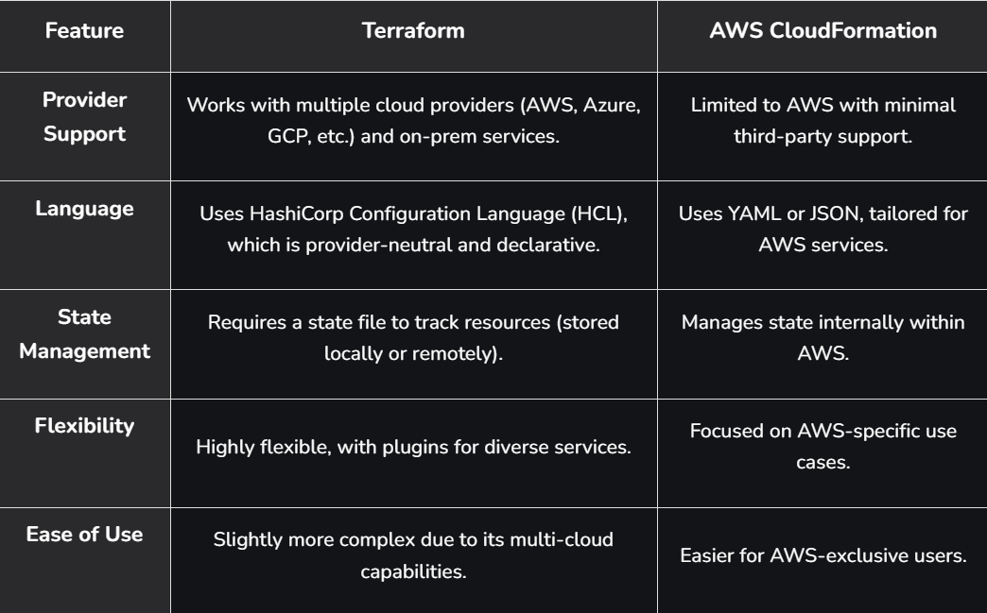
2. Terraform vs Ansible:
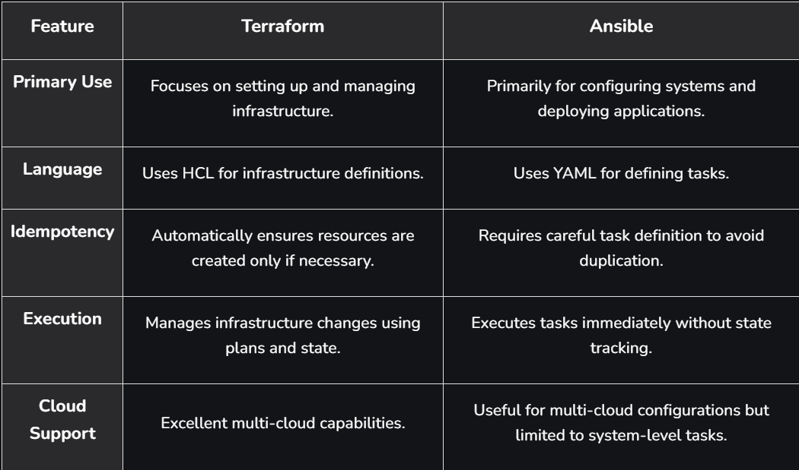
3. Terraform vs Chef:
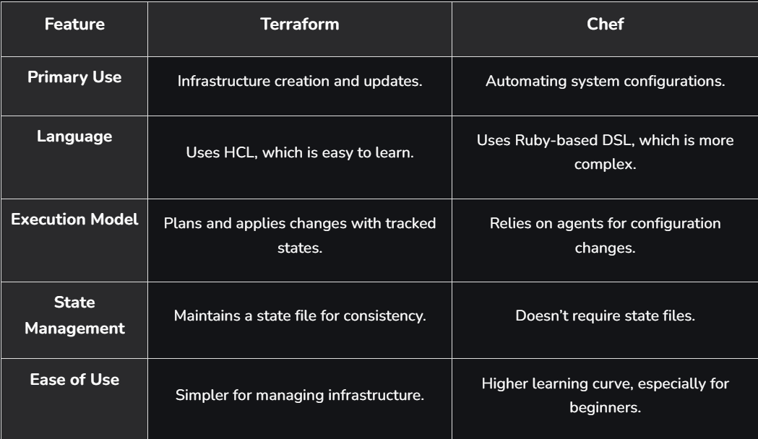
*********************************************************************************************************************************************************************************************************************************************************************************************

Section 2: TERRAFORM WORKFLOW:
Terraform is an open-source Infrastructure as Code (IaC) tool developed by HashiCorp.

Core Function and Features:
- Defines and Manages Infrastructure: It allows you to define, provision, and manage your infrastructure resources.
- Declarative Language: It uses the HashiCorp Configuration Language (HCL), a declarative language, to describe the desired state of the infrastructure.
- Configuration Files: Configuration files specify the resources, their properties, and the relationships between them.
- IaC Benefits: By treating infrastructure as code, Terraform enables version control, collaboration, and repeatability.
- Broad Support: It supports a wide range of providers, including:
  - Major cloud platforms (AWS, Azure, GCP)
  - On-premises environments
  - Various services (e.g., DNS providers, CDNs, databases)
Terraform workflow:
1. Define Infrastructure
Create a directory for your Terraform project and define your infrastructure using Terraform configuration files. These files describe the desired state of your infrastructure resources, such as virtual machines, networks, databases, and more. The main configuration file is usually named main.tf, but you can split the configuration across multiple files as needed.
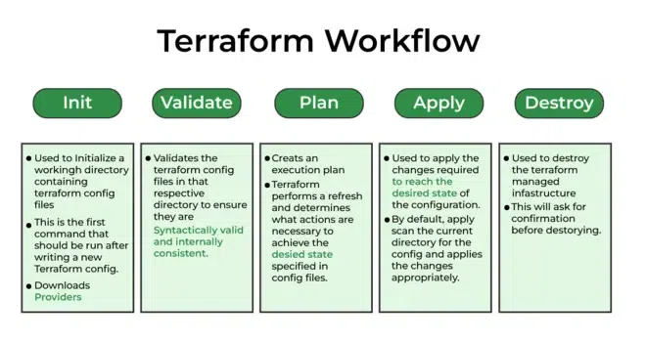
2. Terraform Initialize
In the project directory, run Terraform init to initialize Terraform. This command downloads the necessary provider plugins and sets up the backend configuration. The backend configuration determines where Terraform stores its state file, which tracks the current state of your infrastructure. Now run terraform init command in the terminal as shown in the figure below.
terraform init
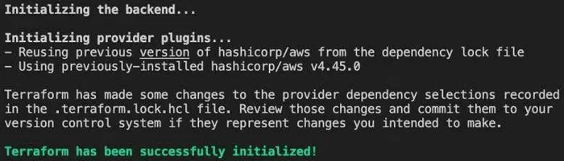
2. Terraform Validate
The Terraform validate command is used to validate the syntax and configuration of your Terraform files without actually applying or modifying any infrastructure. It performs a static analysis of your code and checks for any errors or warnings in the configuration.
To use the Terraform validate command, navigate to the directory containing your Terraform files and execute the following command:
Terraform validate
Here are the typical outcomes of running terraform validation:
- If your Terraform configuration is valid and error-free, the command will exit with a success message, indicating that the configuration is syntactically correct.
- If there are any syntax errors or issues in your Terraform files, the command will display specific error messages pointing to the problematic lines or elements in your configuration.
Example output:
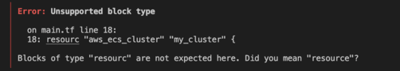
In this case, you need to review the error message, correct the syntax issue, and run Terraform validate again until the configuration is error-free.
Note that terraform validation only checks for syntax errors and basic configuration issues. It does not perform any validation against the actual resources or services you are provisioning. For a more thorough validation that includes checking for potential errors and issues related to specific providers, you can use the terraform init command followed by terraform plan.
By regularly running Terraform validate during your development process, you can catch syntax errors early and ensure that your Terraform configuration is properly structured and ready for execution.
3. Terraform Plan
Run terraform plan to create an execution plan. This command analyzes your configuration and compares it with the current state, identifying the changes necessary to achieve the desired state. It provides an overview of what resources will be created, modified, or deleted. Now add terraform plan command you will see the execution plan by terraform.
terraform plan
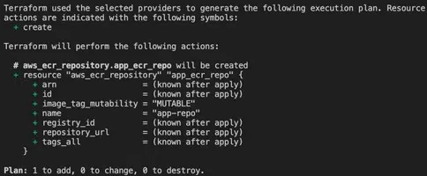
4. Terraform Apply
Use Terraform apply to execute the plan and apply the changes to your infrastructure. Terraform prompts for confirmation before proceeding. Once confirmed, it provisions the resources according to your configuration and updates the state file. Now run terraform apply command you will see this as output and with a resource that you have mentioned.
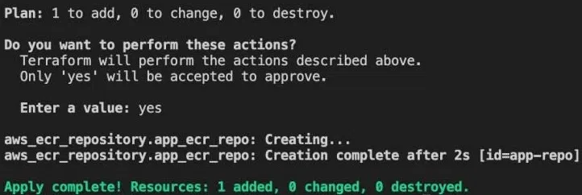
5. Review and Iterate
After applying the changes, review the resulting infrastructure. You can validate that the resources were created correctly and are functioning as expected. If necessary, iterate on your configuration by making modifications to the Terraform files and repeating steps 3 to 5.
6. Terraform Destroy
When you want to tear down the infrastructure, use Terraform destroy. This command reads the state file and destroys all the resources managed by Terraform. It's important to exercise caution with this command as it permanently deletes resources.
Throughout the workflow, it's crucial to maintain the Terraform state file, which tracks the current state of your infrastructure. This file should be stored securely and version-controlled to ensure consistency and facilitate collaboration.
Additionally, you can use other Terraform commands and features as needed, such as Terraform validate to check your configuration for syntax errors, terraform state to interact with the state file directly, and modules to organize and reuse infrastructure code.
It's important to note that while this provides a general workflow, actual practices may vary depending on your specific use case, team processes, and best practices in your organization.
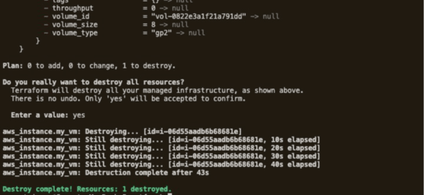
Terraform Code For Aws Provider and Terraform Block
Create a main.tf file and add this code to practice the Workflow mentioned above
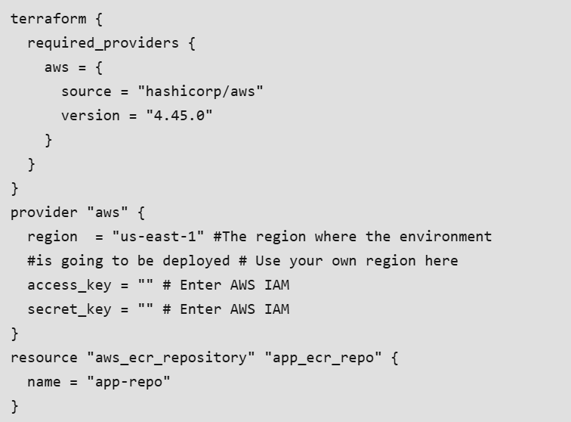
Terraform Block
Specifies the required providers for your Terraform configuration. In this case, it declares that the configuration requires the AWS provider from the "hashicorp/aws" source and expects version 4.45.0. This ensures that the correct provider is available to provision AWS resources.
Provider aws block
Configures the AWS provider. It specifies the region where the environment will be deployed as "us-east-1". Additionally, it requires the access key and secret key, which should be provided for authentication with AWS. You need to replace the empty strings with the actual access key and secret key values associated with your AWS IAM user or role.
Resource block
defines an AWS Elastic Container Registry (ECR) repository resource named "app_ecr_repo". It creates a repository in AWS ECR with the name "app-repo". ECR repositories are used to store and manage Docker container images.
To summarize, the provided Terraform configuration sets up the required AWS provider, specifies the region, access key, and secret key for authentication, and creates an AWS ECR repository resource named "app-repo". By running Terraform apply with this configuration, Terraform will create the specified ECR repository in the AWS region specified.
*********************************************************************************************************************************************************************************************************************************************************************************************
Section 3: TERRAFORM State file:
The Role of Terraform State
Terraform uses a state file to manage and track the relationship between your configuration and the real-world infrastructure it provisions.

Key Points on Terraform State:
- Location: By default, the state is stored locally in a file named terraform.tfstate.
- Purpose:
  - It maps the resources declared in your HashiCorp Configuration Language (HCL) configuration files to the actual objects in the remote system (e.g., cloud provider).
  - It tracks metadata and resource information for the managed infrastructure.
  - It helps boost efficiency when managing large infrastructures.
- How it Works:
  - Terraform uses the state to determine which infrastructure changes to make during an operation (like apply).
  - Before any operation, Terraform performs a refresh to ensure the state file reflects the current, actual status of the remote infrastructure.
  - When a remote object is created due to a configuration change, Terraform records the remote object's unique identification against the specific resource instance in the state.
  - This tracking allows Terraform to safely and predictably update or delete that specific object in response to future configuration changes.
Terraform State File Structure:
Terraform state files contain each and every detail of any resources along with their current status whether it is "ACTIVE", "DELETED" or "PROVISIONING" etc.
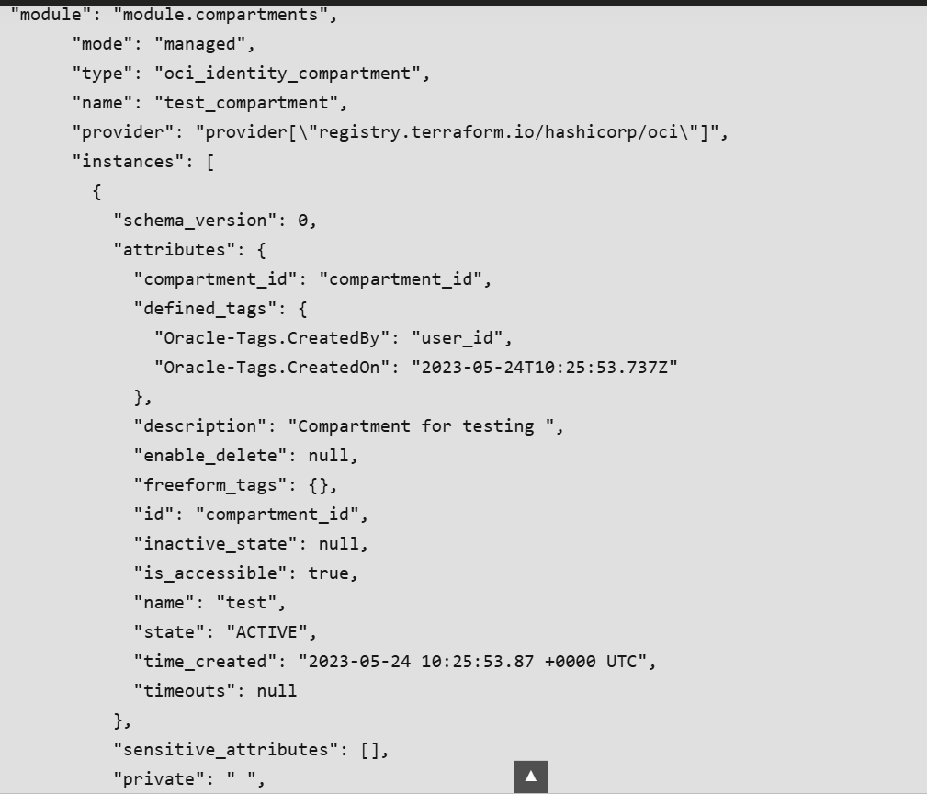
Storing Terraform State Files
By default, Terraform saves state files locally in the directory where you run it. This is fine for personal projects or testing, but when working in teams or using automation tools (like CI/CD pipelines), storing state locally becomes a problem. In team environments, multiple people need to access the state file, and automation needs to read and write it as well.
To solve this, it's better to store the state file remotely instead of on your local machine. Services like Azure Storage Accounts or Amazon S3 buckets work well for this purpose. Remote storage ensures that the state file is accessible to everyone who needs it, while allowing you to control permissions.
Here’s an example of how to configure a remote backend using Azure:
terraform {
backend "azurerm" {
resource_group_name = "terraform-rg"
storage_account_name = "terraformsa"
container_name = "terraformstate"
key = "terraform.tfstate"
}
}
It’s important not to store state files in source control because they might contain sensitive data, like secrets. You can use services like Azure Key Vault to keep secrets secure. Version control systems don’t allow locking files, which means people might overwrite each other’s work when accessing the state file. Using a remote backend resolves this by supporting file locks, automatic loading, encryption, and versioning. Plus, it's typically inexpensive.
Organizing and Isolating State Files:
To reduce risk and make it easier to manage your infrastructure, it’s best to isolate your state files. If everything is in a single state file, a change to one resource could unintentionally affect others.
A better approach is to use separate state files for different parts of your infrastructure, or different environments. For example, you might want separate state files for development, testing, and production. Here’s how you could organize state files in Azure Storage:
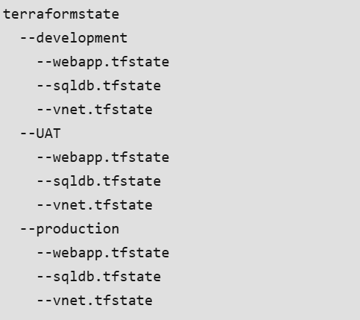
Each environment and resource has its own state file, so changes to one environment won’t affect another. For example, the backend configuration for a web app in the development environment would look like this:
terraform {
backend "azurerm" {
resource_group_name = "terraform-rg"
storage_account_name = "terraformsa"
container_name = "terraformstate"
key = "development/webapp.tfstate"
}
}
Using Workspaces for Isolation:
Another way to manage state files is through Terraform workspaces. Workspaces allow you to quickly isolate environments, though they’re not meant for use in production. Each workspace has its own state file. When you create a new workspace, Terraform sets up a directory to store the state file for that workspace.
Create a new workspace:
$ terraform workspace new development
Created and switched to workspace "development"!
Switch between workspaces:
$ terraform workspace new stage
Created and switched to workspace "stage"!
$ terraform workspace new prod
Created and switched to workspace "prod"!
Define variables based on the selected workspace
locals {
cidr_block = terraform.workspace == "dev" ? "10.0.0.0/16" : terraform.workspace == "stage" ? "11.0.0.0/16" : "12.0.0.0/16"
}
output "cidr_block" {
value = local.cidr_block
}
Switch to a workspace and apply changes:
$ terraform workspace select dev
Switched to workspace "dev".
$ terraform apply
By using workspaces, Terraform will keep separate state files for each environment. You can list your workspaces with:
$ terraform workspace list
* dev
stage
prod
This makes it easy to manage separate environments without accidentally changing something you didn’t mean to. You can isolate your work and keep environments clean.
Manage Terraform State File:
1. Local File
When we don't define any object storage or bucket to store these files, by default, these states get stored in a local file named "terraform.tfstate" . The disadvantage of using local files to store states is that every team member will have their own local state file, and this local state file will be different for sure. And it will create discrepancies for all resource states, and you might not be able to deploy the resources until you delete or modify the required state of the resource.We would recommend always using an object storage and configuring the backend to store state files.
2. Using Object Storage To Store State Files And Configure The Backend
We can explicitly defined a bucket to store the state files . For that we have to configure the backend . Create block "backend" inside "terraform" block and define these thing as listed below.
Configure the [default] entry in the credentials file with the appropriate Object Storage credentials. Following is an example of Object Storage credentials:
[default]
aws_access_key_id=ae37c0....
aws_secret_access_key=mSTd.....
Where aws_access_key_id and aws_secret_access_key are user-specific values provided from the Console, mapped to the Object Storage parameters objectStoreKey and objectStoreSecret respectively.
Get Access of Key and Id
Open the navigation menu in cloud and click Identity & Security. Under Identity, click Users. Under User Details, click generate Customer Secret Key.
Code to find
terraform {
backend "s3" {
bucket = "bucket-name"
key = "statefilename.tfstate"
region = "valid-cloud-region-name"
endpoint = "object-storage-bucket-url"
shared_credentials_file = "./credential-file-name"
skip_region_validation = true
skip_credentials_validation = true
skip_metadata_api_check = true
force_path_style = true
}
}
endpoint : https://<namespace>.compat.objectstorage.<region>.<domainname>.com
region : us-phoenix-1
Terraform init
To know how terraform plan works refer to Terraform plan
terraform init
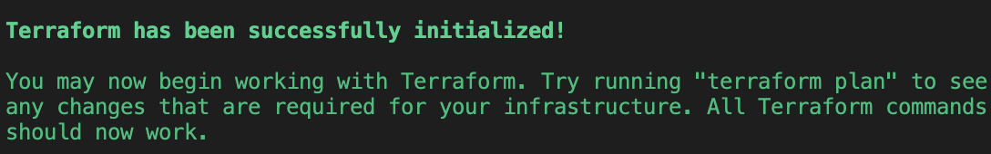
In bucket , empty state file will gets generated
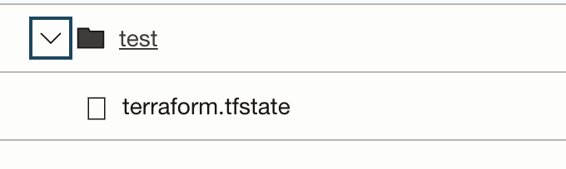
Now run terraform apply command:
terraform apply
Terraform State Commands:
- terraform state list: This command shows all the resources that Terraform is currently managing in the state file.
- terraform state rm: Use this command to remove a resource from the state file. It doesn’t affect the actual resource in your infrastructure; it just removes it from Terraform’s control.
- terraform state show: This command displays detailed information about a specific resource in your state file.
Terraform Remote State
Remote state is a way to store your Terraform state file in a shared, secure location, instead of keeping it locally. This is especially useful when working in a team, ensuring everyone can access and modify the infrastructure without issues.
1. Use of Remote State
- Team Collaboration: Multiple team members can access and work on the same infrastructure without overwriting each other's changes.
- State Locking: Remote backends usually support state locking, which ensures that only one person can modify the state at a time, avoiding conflicts.
- Security: Storing state remotely ensures that sensitive data can be encrypted both in transit and at rest.
- Version Control: Remote backends often provide versioning, which makes it easy to roll back if something goes wrong.
- Consistency: Using remote state guarantees that everyone is working with the same version of the state file, avoiding discrepancies.
Best Practices for Managing Terraform State
- Store State Remotely: Avoid storing state files locally, especially when working with a team. Using remote backends ensures smooth collaboration and prevents conflicts.
- Enable Encryption: Always encrypt your state files, both while they’re stored and while they’re in transit, to keep sensitive data safe.
- Review Plans Before Applying: Take the time to review your Terraform plans before applying them. This helps you understand the changes and their potential effects on your infrastructure.
- Version Your Configurations and Use Modules: Keep your configurations under version control for easy rollbacks. Using modules can further simplify management and allow for smoother updates.
- Consider Automation Tools: Tools like Spacelift can help automate state management and improve collaboration without requiring manual effort.
Advantages of using object storage for storing state file
- State file are stored in a centralised way . So Every team can access same state files and deploy each resource with their latest and correct state
- If supported by your backend, Terraform will lock your state for all operations that could write state. This prevents others from acquiring the lock and potentially corrupting your state.
- State locking happens automatically on all operations that could write state. You won't see any message that it is happening. If state locking fails, Terraform will not continue.
Troubleshooting Terraform State File Errors
1. Bucket does not exist : Make sure to create a bucket before initialising the s3 backend .
2. Invalid endpoint : Please recheck the defined endpoint url , it should be in following format :
- https://<namespace>.compat.objectstorage.<region>.<domainname>.com
where namespace you can see in tenancy details page , region should be any valid region associated with any cloud service provider.
3. credential-file-name does not exist : This file should be in root folder or define exact location of this file in case you are keeping it somewhere else .
4. No credential found : Make sure to name the profile with [default] . This file can have multiples profiles.
[default]
aws_access_key_id=ae37c0....
aws_secret_access_key=mSTd.....
*********************************************************************************************************************************************************************************************************************************************************************************************
Section 4: TERRAFORM MODULE BLOCK:
Terraform Modules
A module in Terraform is a group of Terraform configurations that may be used to build and maintain a certain kind of infrastructure resource. It serves as a building block with a certain configuration, set of resources, and logic. The use of modules, which can be thought of as reusable templates, can help to standardize and make infrastructure provisioning more modular.
Defining a Terraform Module
We make a directory containing a collection of Terraform configuration files in order to define a module. The resource definitions are normally contained in main.tf, input variables are defined in variables.tf, and outputs of the module are configured in outputs.tf. To set variable values, we can also use other files like variables.tfvars.
Syntax of the Terraform Modules Block
Within your primary Terraform setup, you can call and instantiate modules using the modules block. The syntax is:
module "module_name" {
source = "path_of_module"
[other_arguments]
}
module_name: The user-defined name for the module instance is module_name.
source: This identifies the module's location. A remote module registry (like GitHub or Terraform Registry) or a local file path could both be used.
other_arguments: Optional arguments which module can accept as optional arguments.
For example, Let's say we want to set up and provision EC2 instance using a module:
In a different directory, we first define a module called "ec2_instance" with the following structure:
ec2_instance
├── main.tf
├── variables.tf
└── outputs.tf
The required AWS EC2 resource structure is contained in the main.tf file located in the module directory. The module's needed input variables, such as instance type and AMI ID, are defined in the variables.tf file. The outputs of the module, including the instance ID, are specified in the outputs.tf file.
Now, we can instantiate this module as follows in our main Terraform configuration file:

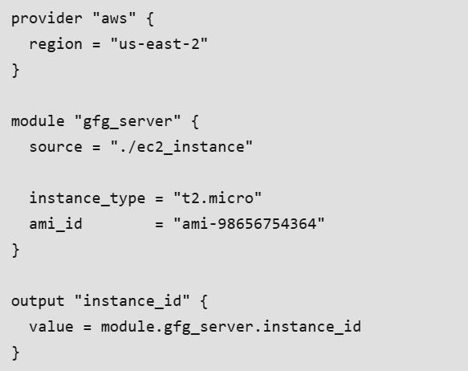
- The region is set to "us-east-2" and the provider block specifies the AWS provider.
- The "gfg_server" module is created by the module block. The module found in the "./ec2_instance" directory is referred to.
- AMI_id is set to "ami-98656754364" and instance_type is set to "t2.micro" inside the module block. The module will use these settings to provision the EC2 instance.
- A "instance_id" output variable is defined in the output block. The "gfg_server" module is accessed to obtain the instance_id output variable's value.
The local file path "./ec2_instance" is used as the module's source in the example above. Following that, we set the instance_type and ami_id input variables' values inside the module block. In order to retrieve the output value of the instance_id output variable declared within the module, we lastly use the module.gfg_server.instance_id reference.
Fundamentals of Modules
Calling a Child Modul
Let's say you have a "vpc" Terraform module that builds a virtual private cloud (VPC) with your cloud provider. You can call this module a child module by using the following syntax to use it in your main Terraform configuration.
module "my_vpc" {
source = "./modules/vpc"
vpc_name = "gfg-vpc"
cidr_block = "10.0.0.0/16"
// etc...
}
In this, the "vpc" module, which is placed in the "./modules/vpc" directory, is called by the module block. Input variables like vpc_name and cidr_block are also provided for configuring the VPC module.
Version
The version attribute can be used to express a module's or provider's version constraint. For
Example:
module "gfg_vpc" {
source = "terraform-aws-modules/vpc/aws"
version = "~> 2.0"
// etc ...
}
In this instance, the "terraform-aws-modules/vpc/aws" module repository is being used to source the module. Versions greater than or equal to 2.0 but are less than 3.0 are allowed, as specified in the version attribute.
Meta-arguments
Let's have a look at the count meta-argument, which enables the creation of many instances of a resource depending on a count value.
resource "aws_instance" "gfg_instances" {
count = 2
ami = "ami-3uir3215678"
instance_type = "t2.micro"
// etc..
}
By repeatedly iterating over the resource block with the count value of 2, Terraform will in this instance construct two AWS EC2 instances.
Accessing Module Output Values
Let's say you have a module called "app" that generates a DNS name for an application load balancer (ALB) that it creates. You can use the name of the module and the output name in the following format to access this output value in your primary configuration:
module "gfg_app" {
source = "./modules/app"
// etc..
}
resource "aws_route53_record" "app_dns" {
zone_id = "ABC123456"
name = "gfg-app.example.com"
// etc..
records = [module.gfg_app.alb_dns_name]
}
In this illustration, the output value alb_dns_name set in the "app" module is referred to by the module.gfg_app.alb_dns_name. In order to create an AWS Route 53 DNS record, it fetches the ALB's DNS name.
Transferring Resource State Into Modules:
Assume you currently handle an AWS S3 bucket outside of Terraform. You can use the terraform import command in the following way to import its state into Terraform
terraform import aws_s3_bucket.gfg_bucket gfg-created-bucket
With the help of this command, the current S3 bucket is linked to the Terraform resource aws_s3_bucket.gfg_bucket, enabling Terraform to control its settings.
Replacing Resources Within a Module
Let's say your "security_group" module controls an AWS security group. You may use the Terraform state mv command to swap out the current security group resource by typing the following
terraform state mv aws_security_group.existing sg.new
The current security group resource aws_security_group.existing is moved in this example using the Terraform command state mv to a new address sg. new. With this alternative, you can modify the resource without affecting the module's other resources.
Benefits of Modules:
- Reusability: By encapsulating infrastructure resources and configurations, modules support reusability. They may be easily shared between projects and teams, minimizing effort duplication.
- Abstraction: Modules encapsulate complicated infrastructure provisioning into straightforward, reusable parts. They give customers the ability to design infrastructure at a more abstract level, which makes it simpler to reason about and maintain.
- Separation of Concerns: By establishing distinct boundaries between various components of the infrastructure, modules enable the separation of concerns. This enhances teamwork and makes it easier for independent module creation and testing.
- Maintainability: Updating and maintaining infrastructure configurations is made simpler via modules. Modifications to a module spread to all instances, guaranteeing uniform and standardized deployments.
*********************************************************************************************************************************************************************************************************************************************************************************************

